Name – Rohit Ranjan Reg No- 22MCA10071

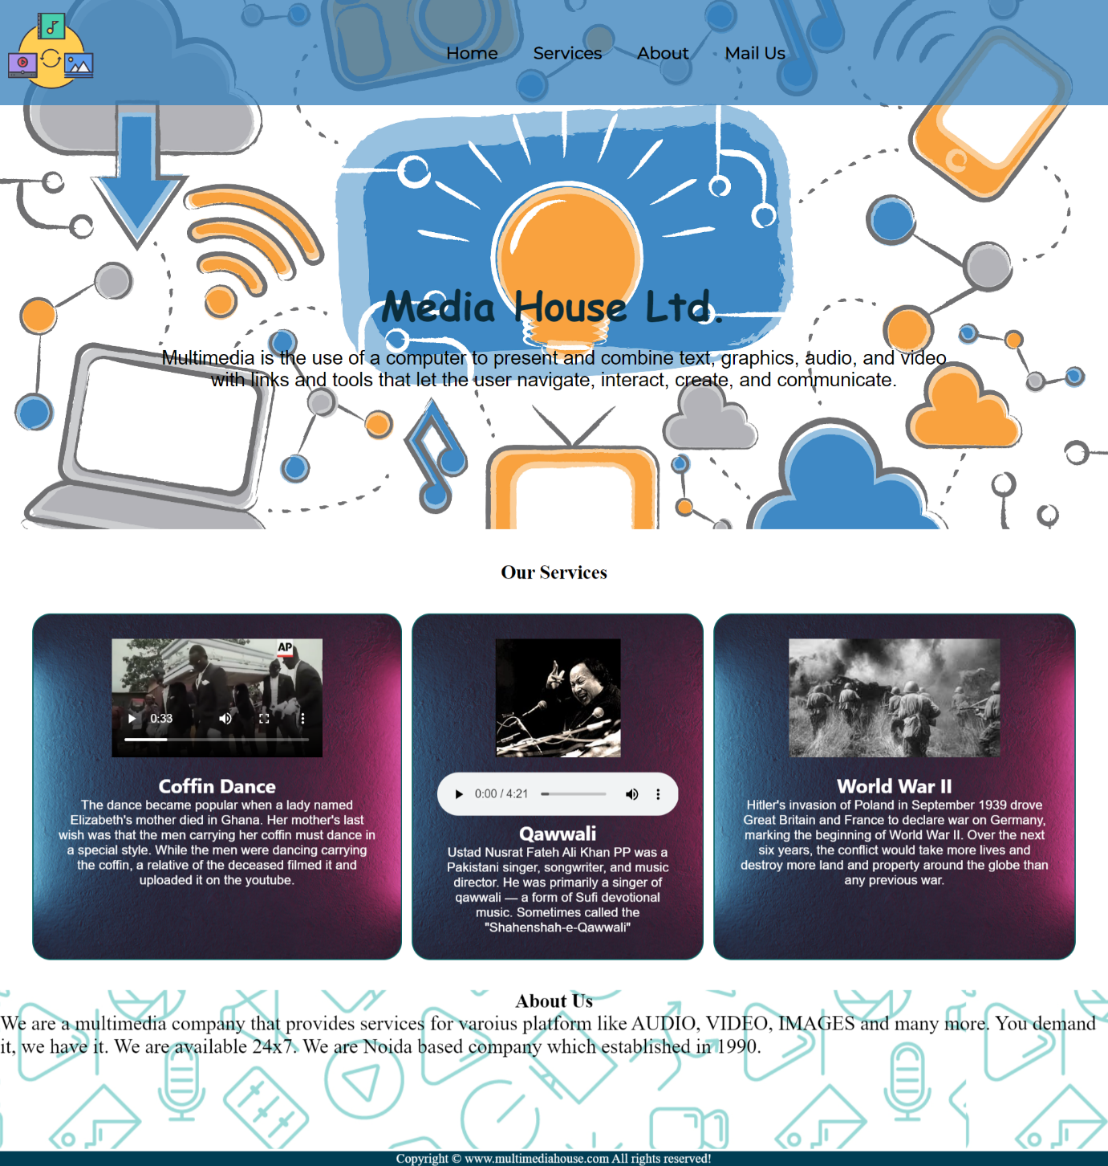

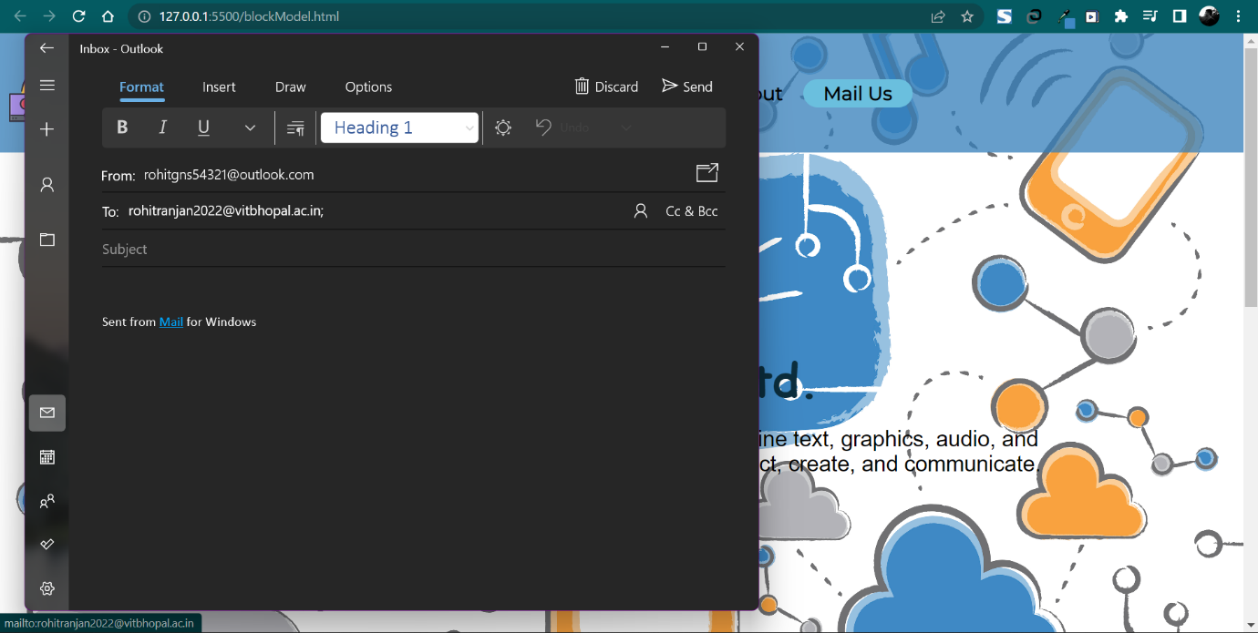Mail in form of link

Code:

**blockModel.html**

<!DOCTYPE html>

<html lang="en">

<head>

    <meta charset="UTF-8">

    <meta http-equiv="X-UA-Compatible" content="IE=edge">

    <meta name="viewport" content="width=device-width, initial-scale=1.0">

    <link rel="stylesheet" href="blockCss.css">

    <title>Media House</title>

</head>

<body>

    <nav id="navBar">

        <div>

            <img src="logo2.png" alt="My logo" id="logoimg">

        </div>

        <ul>

            <li class="item"><a href="#home">Home</a></li>

            <li class="item"><a href="#services">Services</a></li>

            <li class="item"><a href="#clientsection">About</a></li>

            <li class="item"><a href="mailto:rohitranjan2022@vitbhopal.ac.in">Mail Us</a></li>

        </ul>

    </nav>

    <section id="home">

        <h1 class="hprimary">Media House Ltd.</h1>

        <br>

        <p>Multimedia is the use of a computer to present and combine text, graphics, audio, and video with links and tools that let the user navigate, interact, create, and communicate.</p>

        <!-- <button class="btn">Order Now</button> -->

    </section>

    <section id="servicescontainer">

        <h1 class="hprimary center">Our Services</h1>

        <div id="services">

            <div class="box">

                <!-- <img src="food1.jpg" alt="food1"> -->

                <video controls>

                    <source src="videoplayback.mp4" type="video/mp4">

                    Your browser does not support the video tag.

                  </video>

                  <br>

                <h2 class="hsecondary center">Coffin Dance</h2>

                <p class="center">The dance became popular when a lady named Elizabeth's mother died in Ghana. Her mother's last wish was that the men carrying her coffin must dance in a special style. While the men were dancing carrying the coffin, a relative of the deceased filmed it and uploaded it on the youtube.</p>

            </div>

            <div class="box">

                <img src="nusrat.jpg" alt="food1">

                <br>

                <audio controls>

                    <source src="audioo.mp3" type="audio/mpeg">

                    Your browser does not support the audio tag.

                  </audio>

                <h2 class="hsecondary center">Qawwali</h2>

                <p class="center">Ustad Nusrat Fateh Ali Khan PP was a Pakistani singer, songwriter, and music director. He was primarily a singer of qawwali — a form of Sufi devotional music. Sometimes called the "Shahenshah-e-Qawwali"</p>

            </div>

            <div class="box">

                <img src="pic.jfif" alt="food1">

                <br>

                <h2 class="hsecondary center">World War II</h2>

                <p class="center">Hitler's invasion of Poland in September 1939 drove Great Britain and France to declare war on Germany, marking the beginning of World War II. Over the next six years, the conflict would take more lives and destroy more land and property around the globe than any previous war.</p>

            </div>

        </div>

    </section>

    <section id="clientsection">

        <h1 class="hprimary center">About Us</h1>

        <div id="clients">

            <p>

                We are a multimedia company that provides services for varoius platform like AUDIO, VIDEO, IMAGES and many more. You demand it, we have it. We are available 24x7. We are Noida based company which established in 1990.

            </p>

            </div>

        </div>

    </section>

    <section>

        <footer>

            <div class="center">

                Copyright &copy; www.multimediahouse.com All rights reserved!

            </div>

        </footer>

    </section>

  </body>

</html>

**blockCss.css**

/* css reset */

*{

    margin: 0;

    padding: 0;

}

html{

   scroll-behavior: smooth;

}

#navBar{

    background-color: rgba(63, 137, 197, 0.757);

    display: flex;

    align-items: center;

    position: relative;

}

/*  nav:logo and image */

#logoimg{

    margin: 10px 10px;

    height: 20%;

    width: 20%;

}

#navBar ul{

    display: flex;

    font-family: 'Montserrat', sans-serif;

}

#navBar::before{

    content: "";

    background-color: black;

    position: absolute;

    top: 0px;

    left: 0px;

    height: 100%;

    width: 100%;

    z-index: -1;

    opacity: 0.9;

}

#navBar ul li{

    list-style: none;

    font-size: 1.3rem ;

}

#navBar ul li a{

    color: rgb(0, 0, 0);

    display: block;

    font-weight: bold;

    padding: 3px 22px;

    border-radius: 20px;

    text-decoration: none;

}

#navBar ul li a:hover{

    color: black;

    background-color: rgb(106, 191, 222);

}

/* home section */

#home{

    display: flex;

    flex-direction: column;

    padding: 3px 200px;

    justify-content: center;

    align-items: center;

    height: 560px;

}

#home::before{

    content: "";

    position: absolute;

    background: url('back4.jpg') no-repeat center center/cover;

    height: 100%;

    top: 0px;

    left: 0px;

    width: 100%;

    z-index: -1;

    opacity: 0.860;

}

#home h1{

    color: rgb(11, 45, 60);

    font-size: 50px;

    text-align: center;

    font-family: 'Edu QLD Beginner', cursive;

}

#home p{

    color: rgb(0, 0, 0);

    text-align: center;

    font-size: 1.5rem;

    font-family: 'Quicksand', sans-serif;

}

/* services section  */

#services{

    /* background-image: url(./back5.jpg); */

    margin: 34px;

    display: flex;

}

#services .box{

    border: 2px solid rgb(8, 99, 99);

    padding: 30px;

    margin: 3px 6px;

    border-radius: 23px;

    background-image: url(back7.jpg);

    background-position: center;

    background-size: cover;

    /* background: #c9f1ff; */

}

#services .box p{

    color: rgb(255, 255, 255);

    font-family: 'Quicksand', sans-serif;

}

#services .box h2{

    color: rgb(255, 255, 255);

    font-family: 'Segoe UI', Tahoma, Geneva, Verdana, sans-serif;

}

#services .box img{

    height: 147px;

    margin: auto;

    display: block;

}

#services .box video{

    height: 147px;

    margin: auto;

    display: block;

}

/* About us */

#clientsection{

    height: 200px;

}

#clientsection::before{

    content: "";

    position: absolute;

    background: url(back6.jpg);

    width: 100%;

    height: 30%;

    z-index: -1;

    opacity: 0.4;

}

#clients{

    justify-content: center;

    align-items: center;

}

.clientitems{

    padding: 34px;

}

#clients p{

    font-size: 25px;

}

.btn{

    padding: 6px 20px;

    border: 2px solid white;

    border-radius: 8px;

    background-color: turquoise;

    color: rgb(10, 53, 53);

    margin: 17px;

    cursor: pointer;

}

.center{

    text-align: center;

}

footer{

    background: rgb(0, 62, 84);

    color: white;

    padding-right: 9px 20px;

}

.center{

    text-align: center;

}